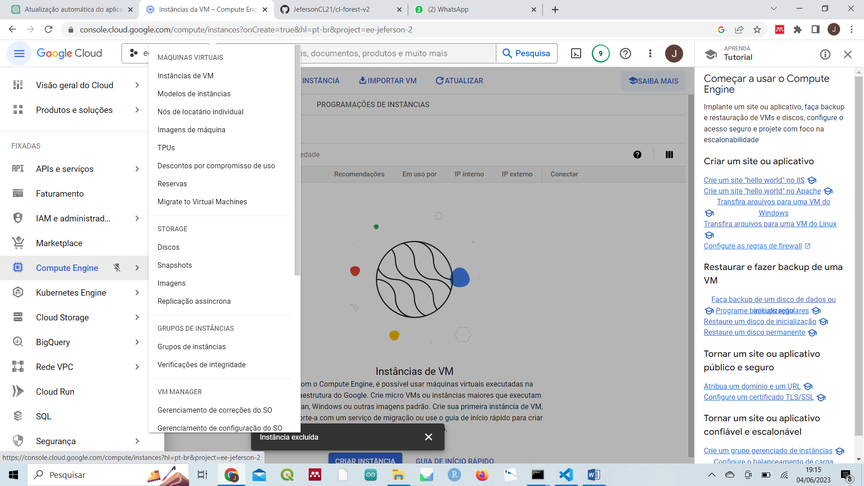

Figura 1-Compute Egine

Figura 2-Criar instancia

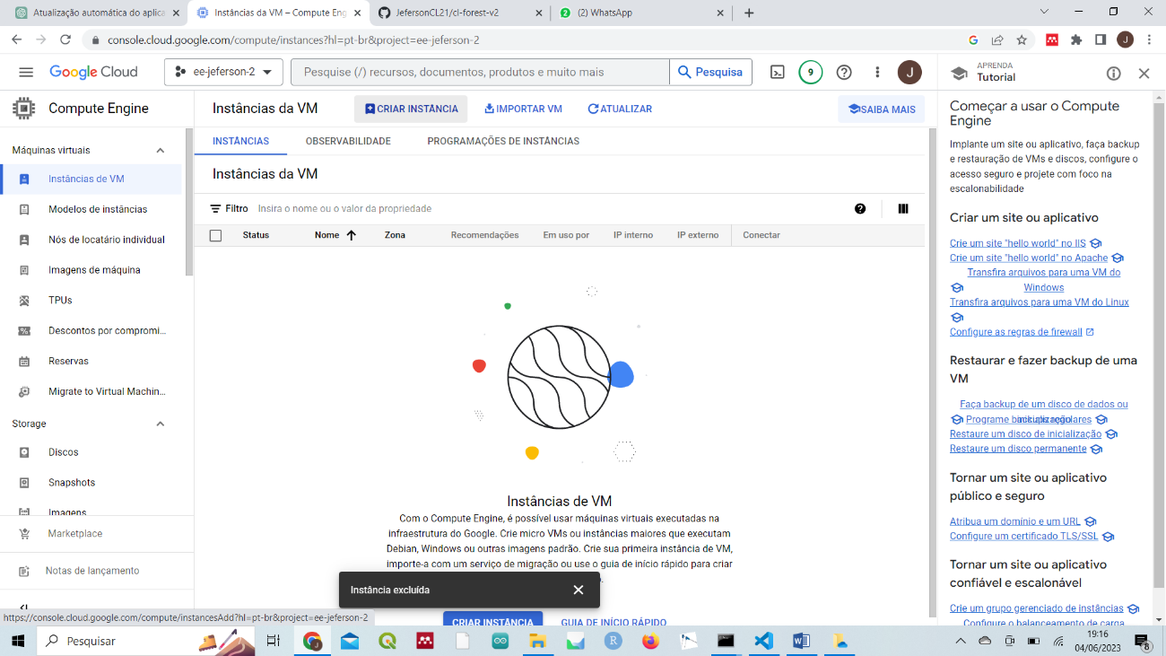

Figura 3-Criar e configurar

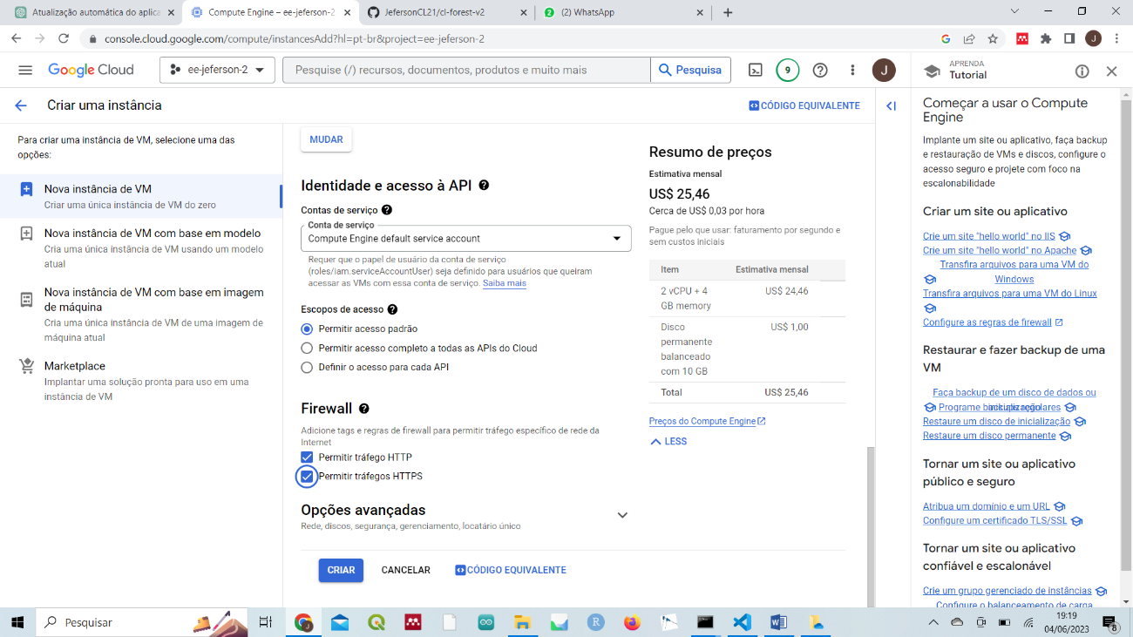

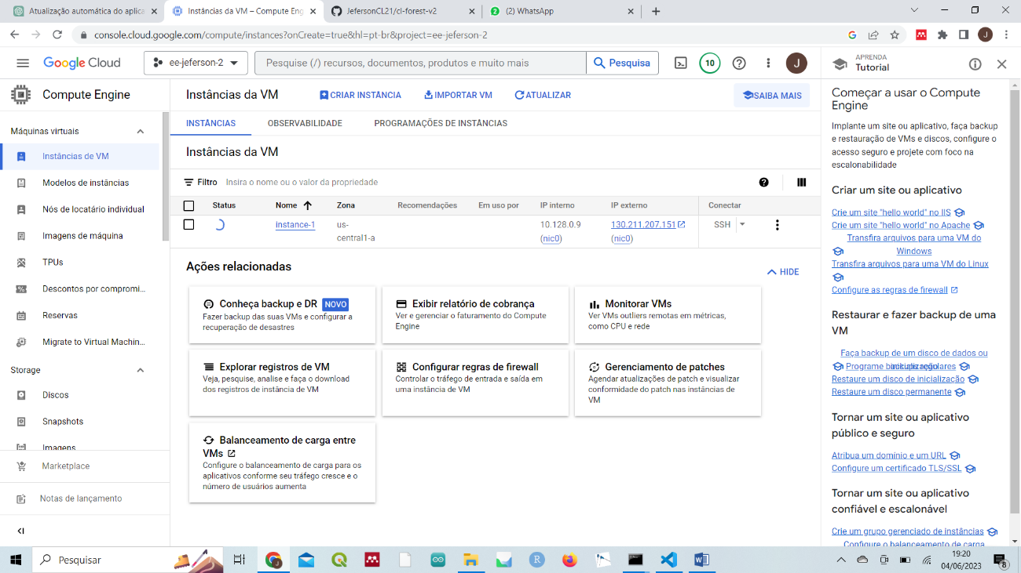

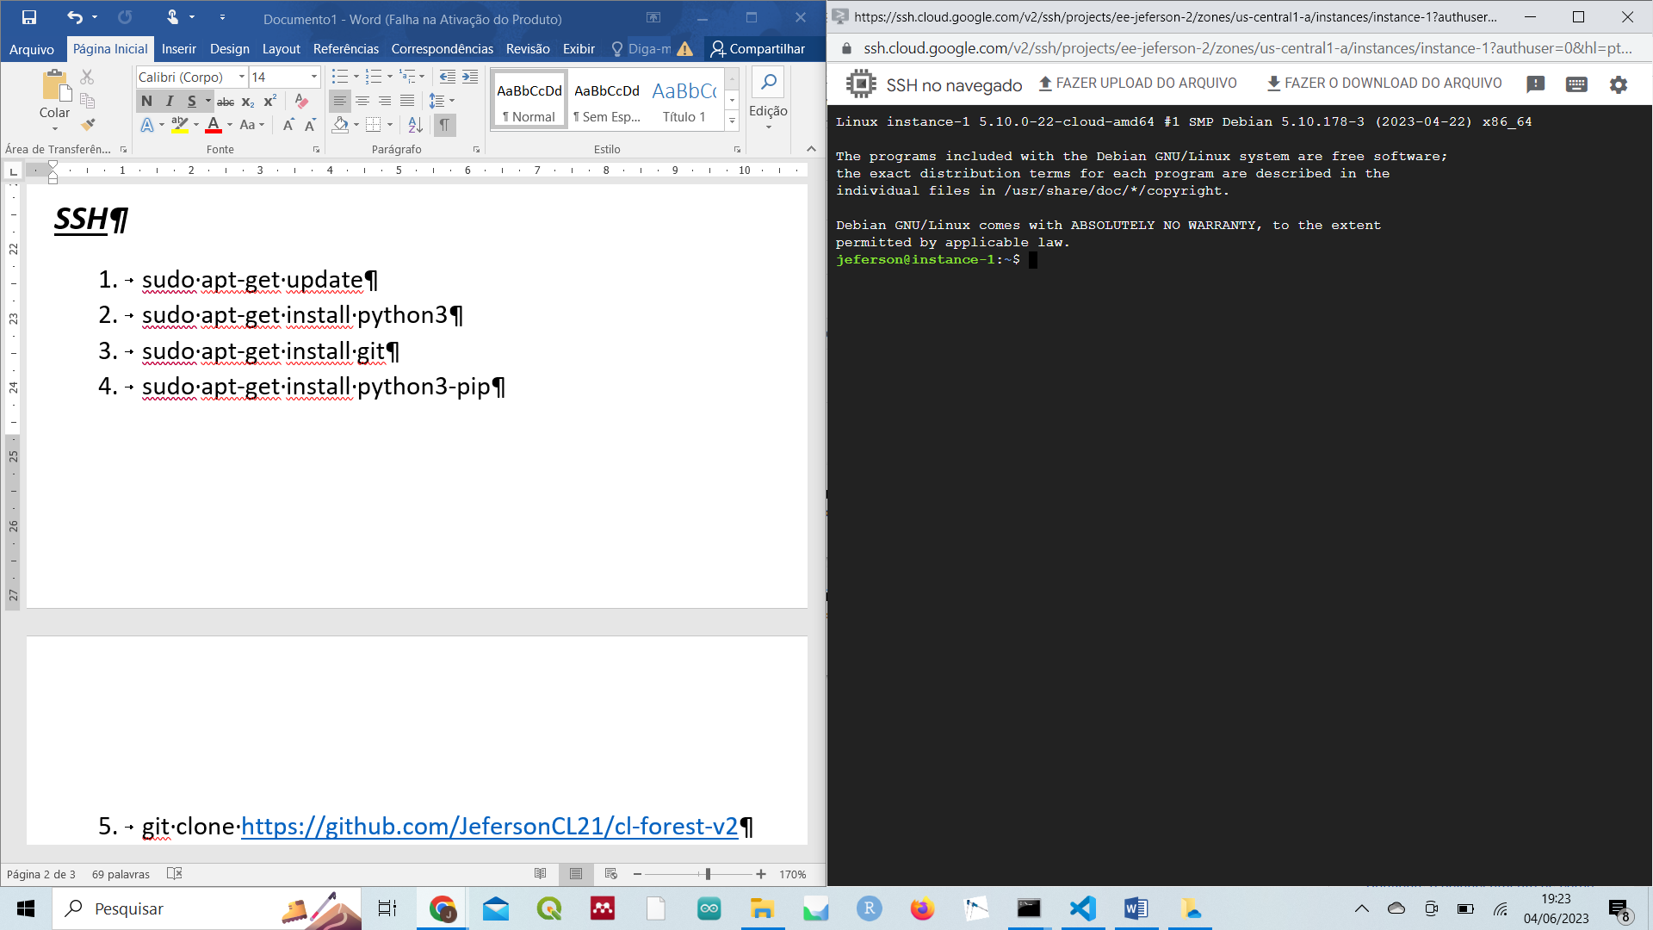

***SSH***

1. sudo apt-get update
2. sudo apt-get install python3
3. sudo apt-get install git
4. sudo apt-get install python3-pip
5. git clone <https://github.com/JefersonCL21/cl-forest-v2>
6. cd cl-forest-v2
7. pip3 install -r requirements.txt
8. export PATH=$PATH:/home/jeferson/.local/bin
9. streamlit run 1_🏠Inicio.py
10. streamlit run 1_🏠Inicio.py --server.port 8501 &

***github***

1. git init .
2. git add .
3. git commit -m "Modificações gerais"
4. git push origin master